**How to deploy book management system**

The book management system includes two applications:

* Backend application Rest-API which developed using Spring Boot, code path /rest-api
* Web Frontend application which developed using Angular, code path /WebFront

The code repository is available on Github: <https://github.com/YuRui1113/book-management-system.git>.

This document will describe how to deploy them to Azure.

1. Database preparation

The backend application uses PostgreSQL database 15.x, uses below steps to create a PostgreSQL database on Auzre.

* 1. Create a PostgreSQL server

Create a PostgreSQL server named “bookrestapi-server”

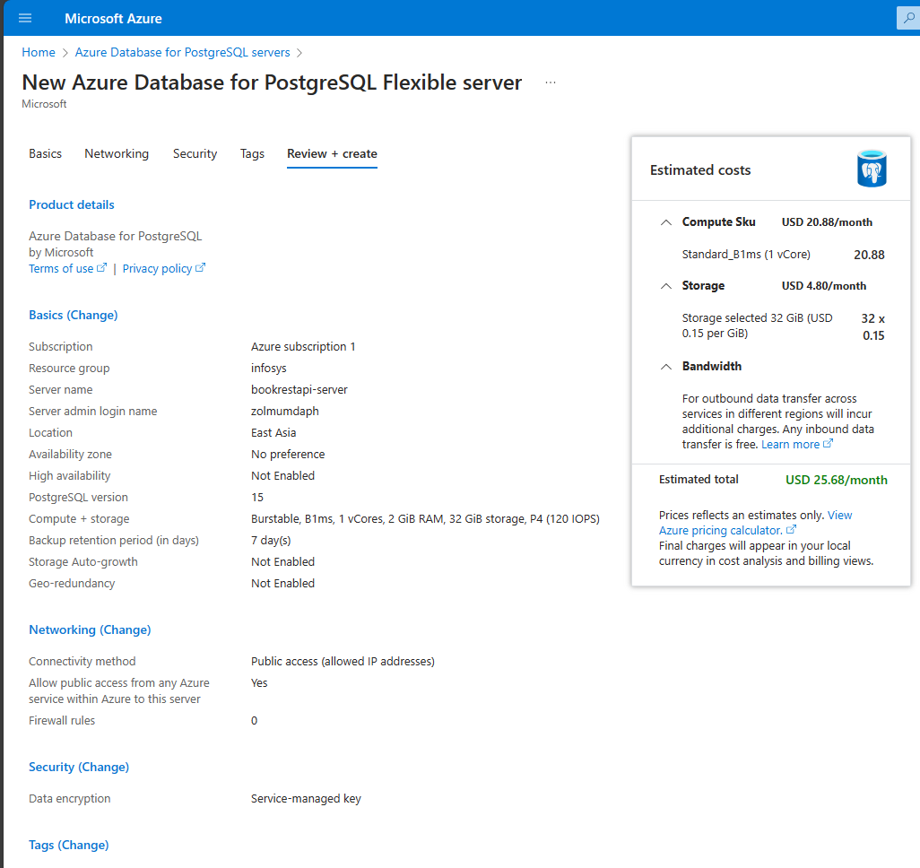

* 1. Create the book database

Create the book database named “bookrestapi-database”

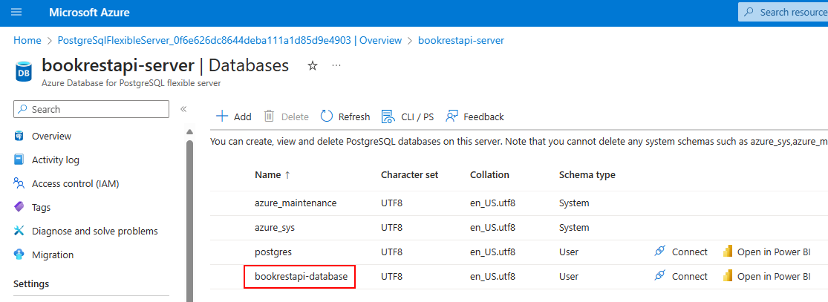

1. Prepare rest API container image
   1. Create configuration file for production on Azure

Create properties file named “application-prod.yml” for production with below contents:

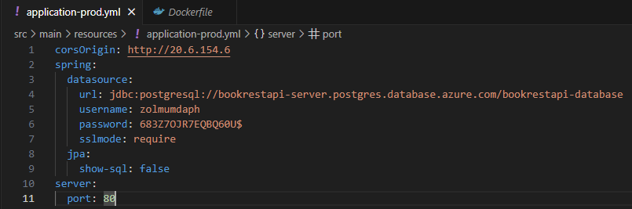

**Notes:** corsOrigin property is the URL of frontend application, you can adjust it after frontend application deployed successfully.

* 1. Create an executable Jar

Enter the project root directory and run below command:

mvn clean package

* 1. Build docker image

Enter the project root directory and run below command:

docker build -t docker.io/yurui113/rest-api .

* 1. Push image to docker public registry

Login to docker public registry

docker login

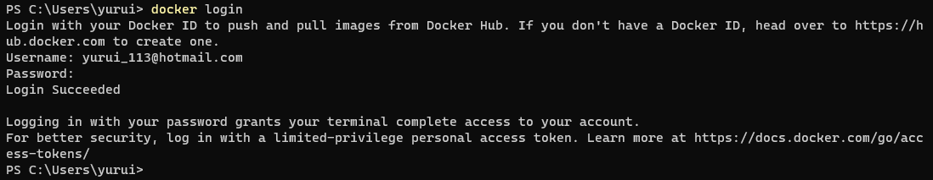

Push image to docker public registry

docker push docker.io/yurui113/rest-api

you will find the new image shown in docker hub.

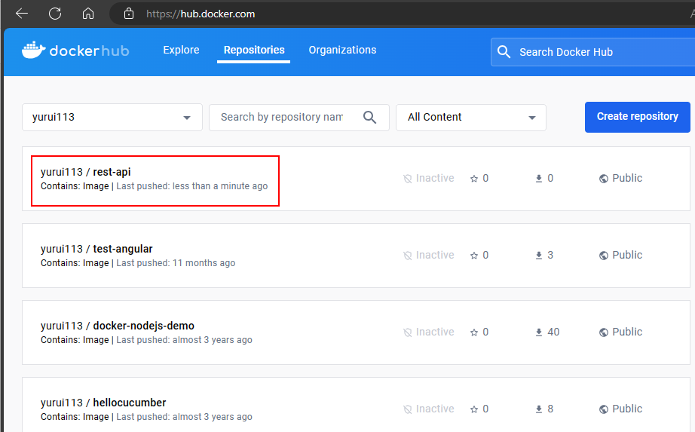

1. Deploy rest API container to Azure

On Azure, create Azure Container Instance with below setting to deploy the container:

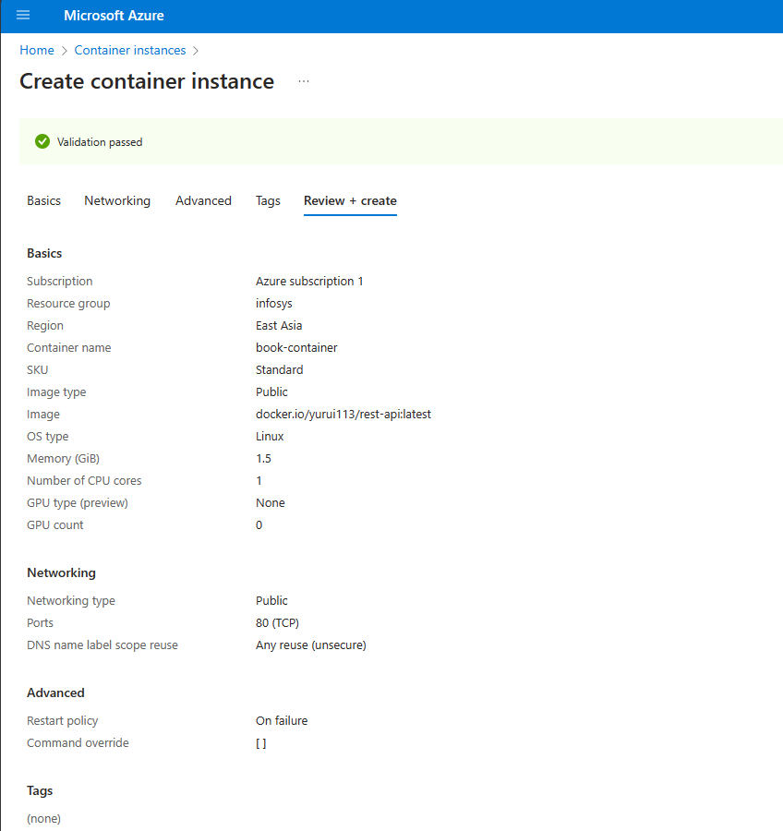

And there is a DNS mapping with domain restapi.tyuapp.top for it, so the container can be tested by view <http://restapi.tyuapp.top/api/v1/book?page=0&size=10>

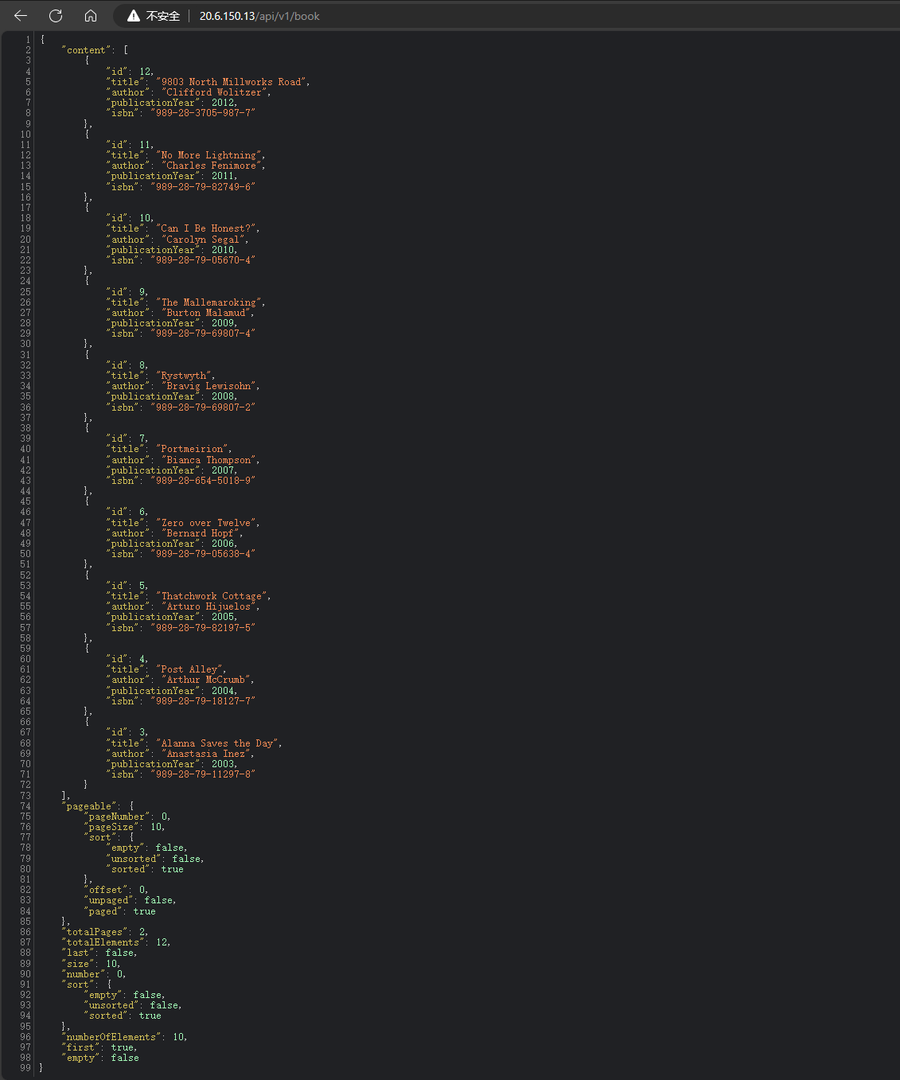

1. Prepare web frontend container image
   1. Create configuration file for production on Azure

Create properties file named “environment.prod.ts” for production with below contents:

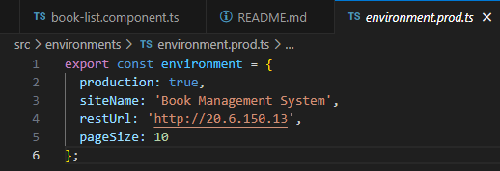

**Notes:** restUrl property is the URL of backend application, you can adjust it after backend application deployed successfully.

* 1. Build Angular application

Enter the project root directory and run below command:

ng build -c production

* 1. Build docker image

Enter the project root directory and run below command:

docker build -t docker.io/yurui113/angular-web-front .

* 1. Push image to docker public registry

Login to docker public registry

docker login

Push image to docker public registry

docker push docker.io/yurui113/angular-web-front

you will find the new image shown in docker hub.

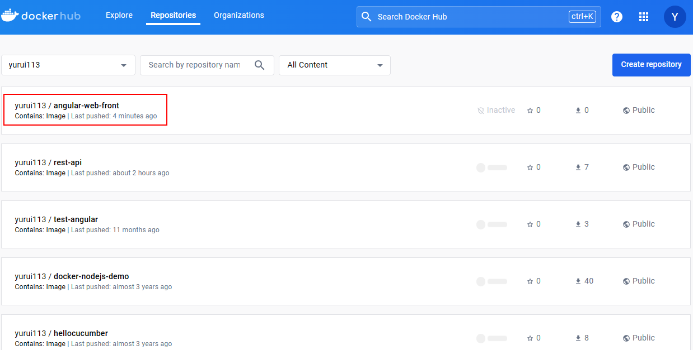

1. Deploy web frontend container to Azure

On Azure, create Azure Container Instance with below setting to deploy the container:

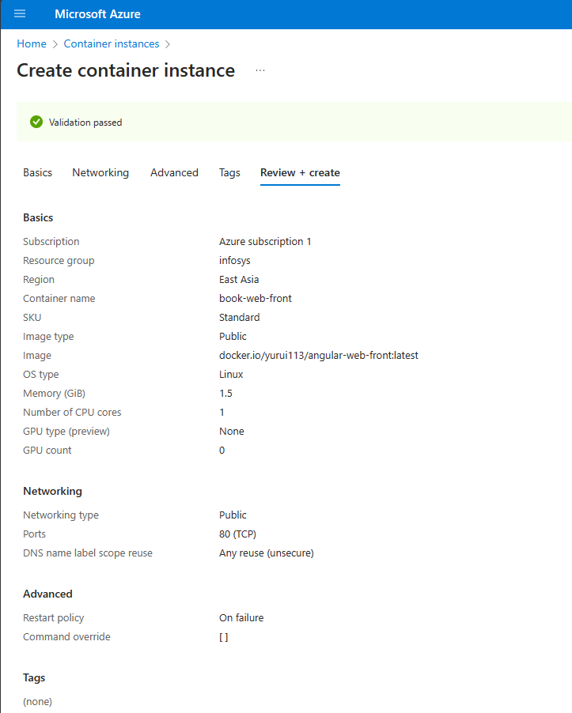

And there is a DNS mapping with domain front.tyuapp.top for it, so the container can be tested by view <http://front.tyuapp.top>.

